**CCN**

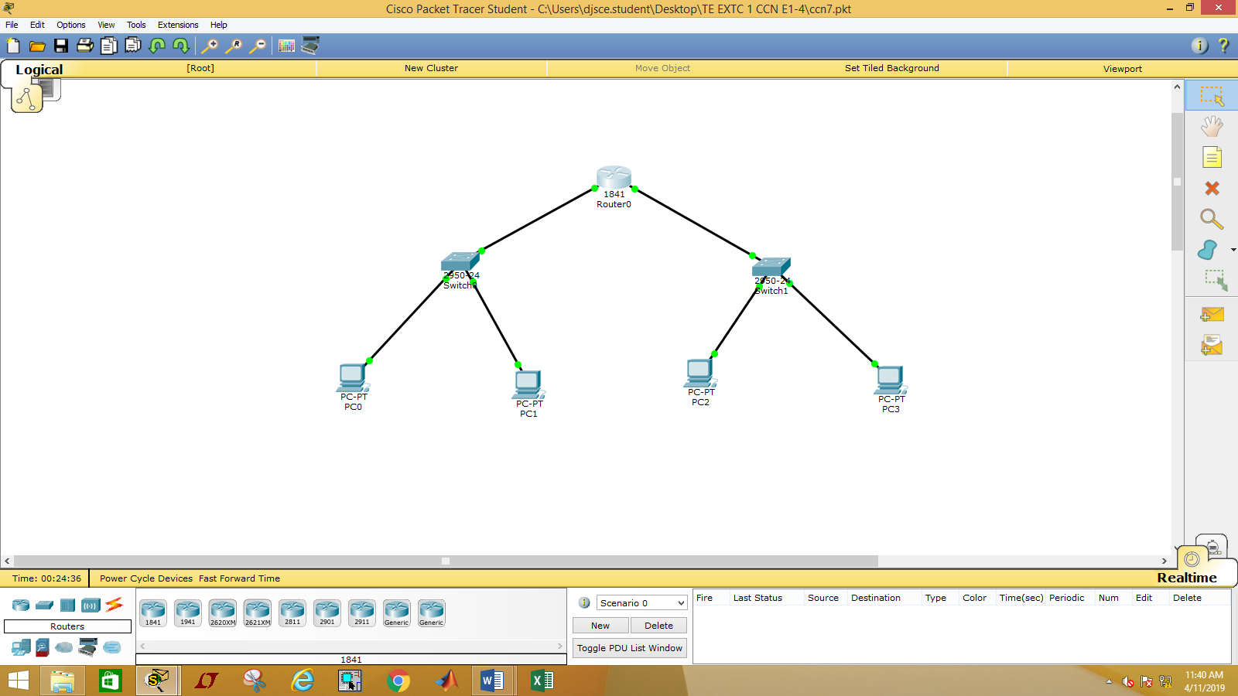

**Task 1 (Standard access-lists)**

*Our task is to give access to 10.0.0.2 from gaining access on 20.0.0.0 network. Other computer from the network of 10.0.0.0 must not be able to connect with the network of 20.0.0.0.*

=>

Router(config)#access-list 1 permit host 10.0.0.2

Router(config)#access-list 1 deny any

Router(config)#interface fa 0/1

Router(config-if)#ip access-group 1 out

Router(config-if)#exit

Router(config)#exit

Router#

%SYS-5-CONFIG_I: Configured from console by console

Router#show ip access-lists

Standard IP access list 1

10 permit host 10.0.0.2

20 deny any

*(Router(config-if)#no ip access-group 1 out)*

**Task 2 (Standard access list)**

*Our task is to block 10.0.0.2 from gaining access on 20.0.0.0. Other computer from the network of 10.0.0.0 must be able to connect with the network of 20.0.0.0.*

=>

Router(config)#access-list 2 deny host 10.0.0.2

Router(config)#access-list 2 permit any

Router(config)#interface fa 0/1

Router(config-if)#ip access-group 2 out

Router(config-if)#exit

Router(config)#exit

Router#

%SYS-5-CONFIG_I: Configured from console by console

Router#show ip access-lists

Standard IP access list 1

10 permit host 10.0.0.2

20 deny any

Standard IP access list 2

10 deny host 10.0.0.2

20 permit any

*(Router(config-if)#no ip access-group 1 out)*

**<For tasks 3 ,4, 5>:**

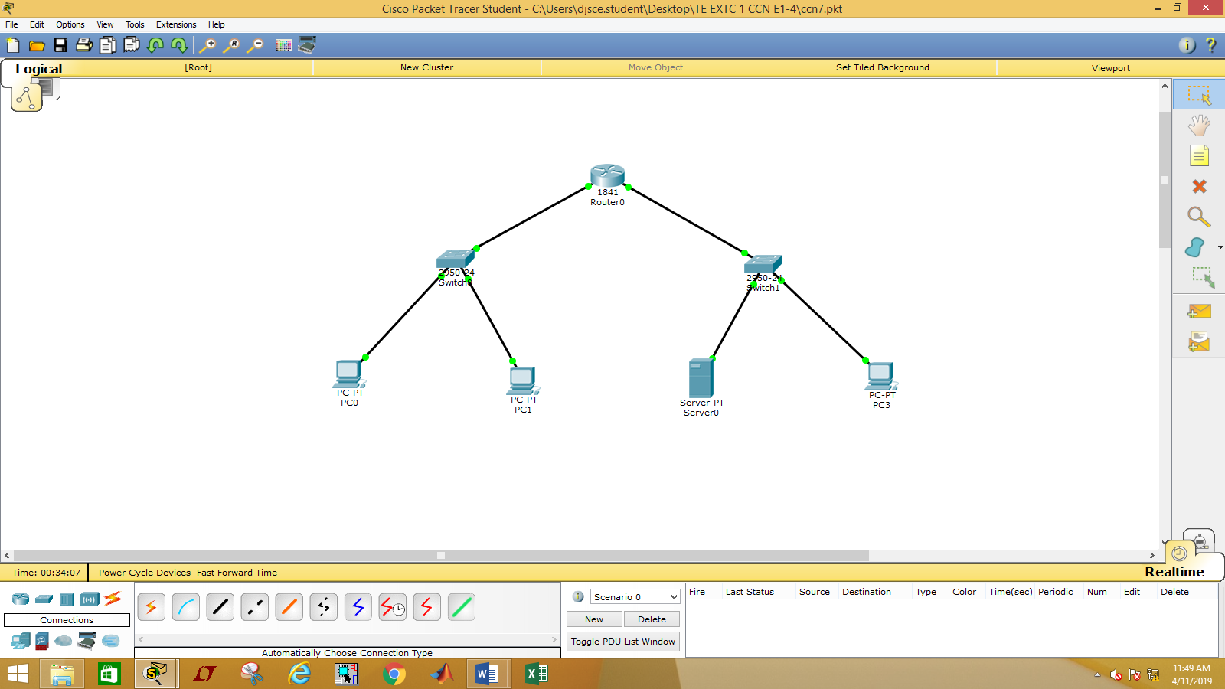

**Task 3 (Extended ACL)**

Our task is to allow HTTP access (server is 20.0.0.2) to 10.0.0.2. All other hosts must not be able to communicate with web server 20.0.0.2*.*

=>

Router(config)#access-list 101 permit tcp any host 10.0.0.2 host 20.0.0.2 eq 80

Router(config)#access-list 101 deny tcp any host 20.0.0.2 eq 80

Router(config)#interface fa0/1

Router(config-if)#ip access-group 101 out

Router(config-if)#exit

Router(config)#exit

Router#

%SYS-5-CONFIG_I: Configured from console by console

Router#show access-lists

Standard IP access list 1

10 permit host 10.0.0.2 (3 match(es))

20 deny any (2 match(es))

Standard IP access list 2

10 deny host 10.0.0.2 (9 match(es))

20 permit any (10 match(es))

Extended IP access list 101

10 permit tcp host 10.0.0.2 host 20.0.0.2 eq www

20 deny tcp any host 20.0.0.2 eq www

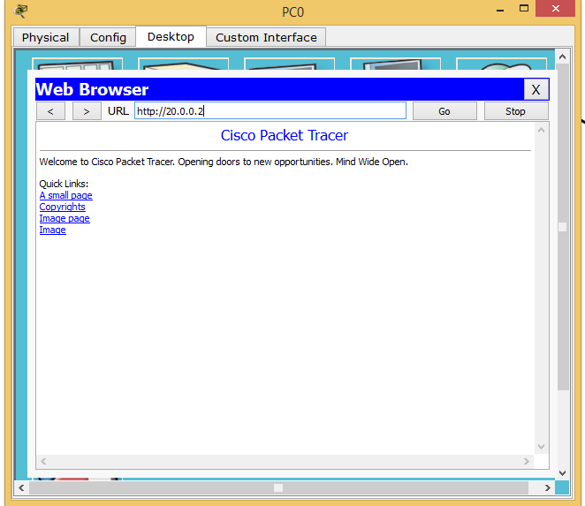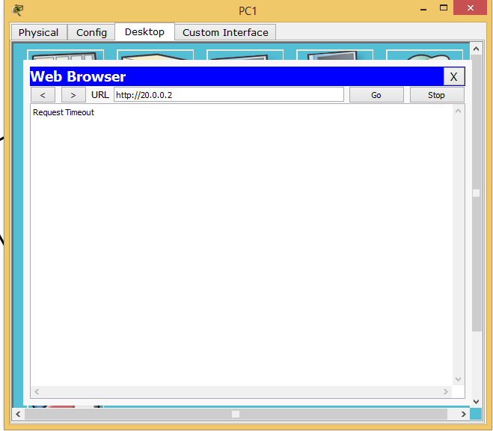

*(Router(config-if)#no ip access-group 101 out)*

**Task 4 (Extended ACL)**

Our task is to deny FTP access (server is 20.0.0.2) to 10.0.0.2. All other hosts must be able to communicate with ftp server 20.0.0.2.

=>

Router(config)#access-list 102 deny tcp host 10.0.0.2 host 20.0.0.2 eq 21

Router(config)#access-list 102 permit tcp any host 20.0.0.2 eq 21

Router(config)#access-list 102 permit ip any any

Router(config)#interface fa 0/1

Router(config-if)#ip access-group 102 out

Router(config-if)#exit

Router(config)#exit

Router#

%SYS-5-CONFIG_I: Configured from console by console

Router#show ip access-lists

Extended IP access list 101

10 permit tcp host 10.0.0.2 host 20.0.0.2 eq www (5 match(es))

20 deny tcp any host 20.0.0.2 eq www (50 match(es))

Extended IP access list 102

10 deny tcp host 10.0.0.2 host 20.0.0.2 eq ftp

20 permit tcp any host 20.0.0.2 eq ftp

30 permit ip any any

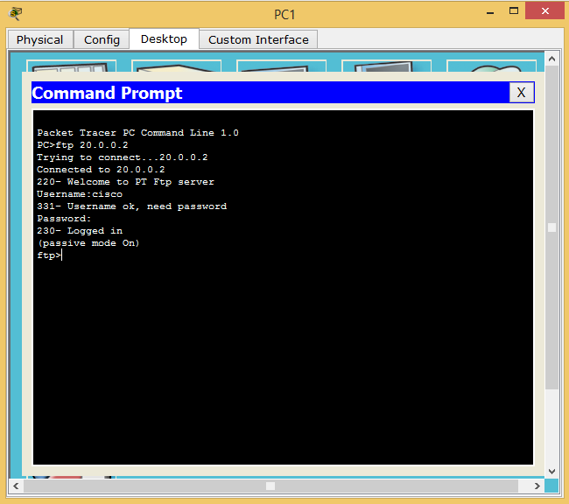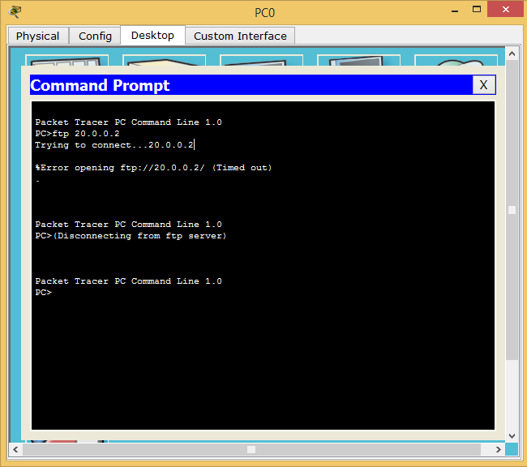

*(Router(config-if)#no ip access-group 102 out)*

**Task 5 (Extended ACL)**

Our task is to deny SMTP access (server is 20.0.0.2) to 10.0.0.2. All other hosts must be able to communicate with smtp server 20.0.0.2.

Router(config)#access-list 103 deny tcp host 10.0.0.2 host 20.0.0.2 eq 25

Router(config)#access-list 103 permit tcp any host 20.0.0.2 eq 25

Router(config)#access-list 103 permit ip any any

Router(config)#interface fa 0/1

Router(config-if)#ip access-group 103 out

Router(config-if)#exit

Router(config)#exit

Router#show ip access-lists

Extended IP access list 103

10 deny tcp host 10.0.0.2 host 20.0.0.2 eq smtp

20 permit tcp any host 20.0.0.2 eq smtp

30 permit ip any any

